Week 7 Pratical
Task:1 Write a program that prints the addresses od code, global, static, heap, and stack varaiables, Analyze the Linux process address space layout and explain each memory segment
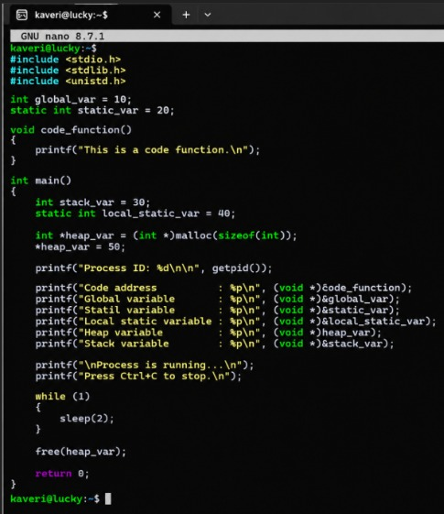
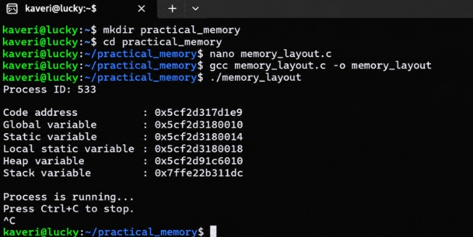
Task:2 Make use of the /pro//maps file and memory analysis tools to study the memory organization of a running process. Preapare a report explaining virtual memory mappings.
